Biker’s Portal Project Report

Aytaç KARA – CE, IKU, Istanbul, Turkey

Enes Hakkı EKİNCİ – CE, IKU, Istanbul, Turkey

Eren Oğulcan KURBAN – CE, IKU, Istanbul, Turkey

Hakan ÇALIŞKAN – CE, IKU, Istanbul, Turkey

Hayri Taha ÇATAR – CE, IKU, Istanbul, Turkey

Onur ENÜSTÜN – CE, IKU, Istanbul, Turkey

**Abstract**—Biker’s Portal is designed for online bike renting without any payment from renters or hirers. Biker’s Portal system shall both running on desktops and mobile environments and available always. The system will a factor between hirers and renters either a person or enterprise. By this way people which have inactively used bikes will earn some money and local bike shops will spread their service to much wider areas for instance whohe city. Also, by this project we conduct people to become more protective to Earth, by using bikes instead of oil-based vehicles. Therefore, protecting the environment and stopping the global warming are important for us.

**Index Terms**—Bike, Bike Hirer, Insurance, Bike Specification, Healthy Life, Global Warming, Message, Rental Enterprise, Requirements, Security, Sign-in/up, Sorting, Ticket

————————————————

1. A. Kara’s E-mail: 1401020064@stu.iku.edu.tr
2. E. H. Ekinci’s E-Mail: 1401020042@stu.iku.edu.tr
3. E. O. Kurban’s E-Mail: 1401020012@stu.iku.edu.tr
4. H. Çalışkan’s E-Mail: 1401020060@stu.iku.edu.tr
5. H. T. Çatar’s E-Mail: 1401020048@stu.iku.edu.tr
6. O. Enüstün’s E-Mail: 1501025004@stu.iku.edu.tr

—————————— ◆ ——————————

# 1 Introductıon

B

iker’s Portal is a bike renting website both running on desktops and mobile environments. Our system provides person-to-person and business-to-person bike rental service.

The user could be bike renter and hirer. The bike hirer can filter bikes for some specifications for example; certain location, the price, technical specification etc. The bike hirer will give a feedback to bike renter to give an idea of the renter for bike hirers. The bike renter can define his bikes specification in detail.

The bike rental enterprises-businesses can come forward in their rivals by giving a fee to Biker’s Portal. In this way bike rental businesses spread their services to a wider area. If the bike hirer takes his service from an enterprise-businesses can benefits a bike damage insurance by without any extra payment so this insurances costs compensated from the enterprise-businesses.

Customer Service assists the users for help to use the websites and resolve the users’ problems. Customer Service also provides an interface to user definition and information adding and updating in the system. Customer Service can be change the certain feedback of users to avoid misunderstandings between renters and hirers.

# 2 Problems

## 2.1 For User

* How do you interact with website without sign-in/up?
* What are the problems with using the website?
* How do you pay the renting cost of bike?
* How do you ensure the damages of bike without an extra payment?

## 2.2 For Bike Hirer

* How do you communicate with bike renter?
* How do you hire the bike?
* What problem do you encounter if you make an accident?
* Who pay the hiring cost of bike?
* When do you pay the hiring cost of bike?

## For Bike Renter

* How do you rent your bike in website?
* What happens if your bike is wrecked?
* What happens if your bike is lost or stolen?
* Who compensates your victimization?

## For Bike Rental Enterprise

* Who compensate the insurance costs, website or your business?
* What are the advantages of being an enterprise?
* How many bikes do you rent at the same time?
* How often answer the hirers requests?

# 3 Requırements

**Functional Requirements:**

**For User:**

1. The user shall enter the website.
   1. The user may surf in the website to see all bikes, prices etc.
   2. The user may leave the website at anytime.
2. The user shall sign-up once the website for access the full features of the system.
   1. The user shall enter a username, password, mobile phone, e-mail, address, and id informations.
   2. The user shall choose membership type either personal or enterprise.
3. The user shall login for access the full features of the website.
   1. The user shall enter the username or e-mail and password to login the website.
   2. The user shall access other users profile for hiring or renting a bike.
4. The user shall communicate with Customer Service.

**1- For Bike Hirer:**

1. The bike hirer is an user for uses the website for hire a bike.
2. The bike hirer shall sort the bikes for some specifications like location, hiring price, feedback points etc.
3. The bike hirer shall communicate with the bike renter for hiring purposes.
4. The bike hirer shall check-in when rent a bike and to deliver back.
5. The bike hirer shall give a feedback about bike and enter a grade for bike renter.

**2- For Bike Renter:**

1. The bike renter is an user for uses the website for rent his or her bike(s).
2. The bike renter shall define specifications like hiring price for certain period, technical specs etc. of his or her bike for rent on website.
3. The bike renter shall communicate with bike hirer by an upcoming request.
4. The bike renter shall update his or her bikes’ availability after an hiring agreement.
5. The bike renter shall check-in when rent a bike and to deliver back.
6. The bike renter shall be either person or enterprise.
   1. The bike rental enterprises shall agree with bike hirer in some insurance contract for protect the hired bike.

**The Customer Service:**

1. The customer service shall be an administrator for the website from the system providers.
2. The customer service shall accessible from both bike hirers and renters and also rental enterprises.
3. The customer service shall solve the problems and misunderstanding may happen between users.
4. The customer service shall keeps a right to permaban any account from violating the usage agreement.

**Non-functional Requirements:**

**Operational:**

* Website available on PCs and Phones.
* Our system has a customer service.

**Performance:**

* Website has done every operation under the 7 seconds.
* For achieving the fast response time the system designers normalize the system’s database.
* The website is accessible at anytime.

**Security:**

* The system stores every users’ credit card information for secure operating.
* The website has a bike deliverance check system.
* Bike insurances will provided from bike rental enterprises themselves, our system is not responsible from this.

**Cultural:**

* The system will serve in English and Turkish languages for supporting localization.

# 4 Dıagrams

## 4.1 Use Case Diagram

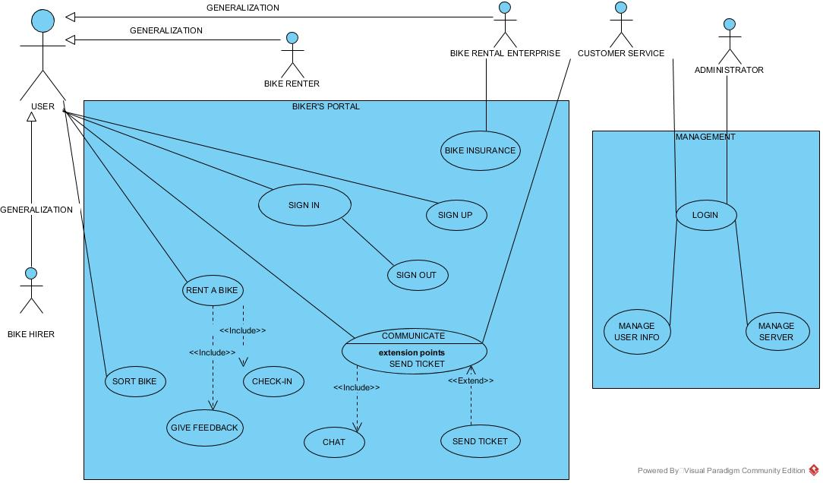

In use our use case diagram, we have 3 main actors, first one is user and that is generalization actor for Bike hirer, renter and rental enterprises. Then we divide our system to two parts; first one is user UI namely Biker’s Portal, second one is management panel. In Biker’s Portal UI user should sign up once and sign in every usage of website, also may sign out whenever she or he wants. Then for rental enterprise we assume there is an insurance service. Then for renting a bike process goes like that; firstly, user sort bikes and choose desired bike and check-in then should give a feedback when agreement ends. The user also communicates both customer service and bike renters. For that purpose, we create communicate use case and append it to chat and send ticket. In management side both customer service and administrator should login the system before doing anything else. Then customer service interests’ user communication and admin should manage user info and server issues.

## 4.2 Activity Diagram

In activity diagram, we divide the whole process to 4 parts; these are client web page, web server, database, and management. All the parts shall communicate each other, and system runs. All the procedures are open and self-explanatory so in paper we only mention some critical points; firstly, user never directly access the database, shall use web server for all registering operations, secondly manager never access the web server, thirdly all operations are returns something and inform the correct user. Finally, all of the operations based on our use case diagram.

## 4.3 EER Diagram

Our EER diagram prepared by using our class diagram and use case diagram and defines operations and actors’ functions and variables which are stored in database. All the variables are open, and we explain only relations in this paper. For user; one user may give a multiple feedback, so we use one-to-many relationship, then one user may take more bikes and may give more messages than one, so we use again one-to-many relationship, and many users may perform same operations then we use many-to-one relationship. Then also between bike and feedback and inrentbike we use one-to-many relationship. And finally, one manager may consider more than one ticket, so we use one-to-many relationship.

# 5 End Sections

## 5.1 Appendix A: About Us

We are university students in Istanbul Kültür University. This website is our term project in Software Engineering course, and our department is Computer Engineering. Our aim to develop this website is make an innovation that is some new area; Online Bike Hiring. In our country there is no online bike hirers except municipality’s website that have only city bikes without any gear mechanism. That’s why we enter the new growing market which is online bike hiring.

## 5.2 Appendix B: Privacy Policy

Biker’s Portal is committed to protecting your privacy and informing you about how your information is used. To provide you with our Service, we need to collect certain information about you, this information is identified and used as following:

Personal Information We Collect from You:

* Identifying Information: You provide us information about yourself, such as your name, age, address, email address, and password, when you register for a Member account with the Service. If you correspond with us by email, we may retain the content of your email messages, your email address and our responses. We may also retain any messages you send through the Service. You may provide us information in User Content you post to the Service. Biker’s Portal does not knowingly collect or save any information from children 13 years of age and younger.
* Usage Information: Biker’s Portal sends a "cookie" to your computer or smart phone that contains an identification number that is unique to the device you are using. We use this cookie to provide you with a seamless experience, and so that we can record how our service is being used. A cookie does not collect personal information about you but may convey anonymous information about how you browse the Service to us. A persistent cookie remains on your hard drive after you close your browser. Persistent cookies may be used by your browser on subsequent visits to the site. Persistent cookies can be removed by following your web browser's directions. A session cookie is temporary and disappears after you close your browser. You can reset your web browser to refuse all cookies or to indicate when a cookie is being sent. However, some features of the Service may not function properly if the ability to accept cookies is disabled.

How We Use Your Information:

* We Will Never Spam You. We will only send you information directly related to your use of Biker’s Portal. By providing Biker’s Portal your email address, you consent to our using the email address to send you Service-related notices, including any notices required by law, in lieu of communication by postal mail. You also agree that we may send you notifications of activity on the Service to the email address you give us, in accordance with any applicable privacy settings. For instance, if you are a Renter, we will send you information about your Ride’s rental status. You can turn these notifications off or modify how often and in what form you receive them. In addition, if you rent through a Shop, we may share your email address and phone number with the Shop so that they may contact regarding your rental and for other marketing purposes. Each Shop will have their own privacy policy, and communications to you from the Shop will be governed by those policies.

How We Share Your Information:

* Biker’s Portal will not rent or sell your personally identifiable information to others. Biker’s Portal may share your personally identifiable information with third parties, including Shops, solely for providing the Service to you. If we do this, such third parties' use of your information will be bound by this Privacy Policy. We may store personal information in locations outside the direct control of Biker’s Portal (for instance, on servers or databases co-located with hosting providers).
* We may share non-personally identifiable information (such as anonymous usage data, referring/exit pages and URLs, platform types, number of clicks, etc.) with interested third parties to help them understand the usage patterns for certain Biker’s Portal services.

How We Protect Your Information:

* Biker’s Portal uses commercially reasonable physical, managerial, and technical safeguards to preserve the integrity and security of your personal information and implement your privacy settings. We cannot, however, ensure or warrant the security of any information you transmit to Biker’s Portal and you do so at your own risk.

You Control Your Information:

* Protecting the privacy of young children is especially important. For that reason, Biker’s Portal does not knowingly collect or solicit personal information from anyone under the age of 13 or knowingly allow such persons to register as Members. If you are under 13, please do not send any information about yourself to us, including your name, address, telephone number, or email address. No one under age 13 can provide any personal information to or on Biker’s Portal. If we learn that we have collected personal information from a child under age 13 without verification of parental consent, we will delete that information as quickly as possible.

Links to Other Web Sites:

* We are not responsible for the practices employed by websites linked to or from the Service, nor the information or content contained therein. Please remember that when you use a link to go from the Service to another website, our Privacy Policy is no longer in effect. Your browsing and interaction on any other website, including those that have a link on our website, is subject to that website's own rules and policies. Please read over those rules and policies before proceeding.

Changes to Our Privacy Policy:

* If we change our privacy policies and procedures, we will post those changes on the Service to keep you aware of what information we collect, how we use it and under what circumstances we may disclose it. Changes to this Privacy Policy are effective when they are posted on this page.

## 5.3 Appendix C: FAQ

Renter’s FAQ:

Q1: Does it cost me anything to list a Bike?

A1: No, usage of website is completely free.

Q2: What if I can only rent my bike out certain days?

A2: No problem! We have an availability calendar where you can mark off the times your bike is completely unavailable, or when you just can't do a drop-off. If your Bike is listed as available, Hirers can request and contact you whenever they want to reserve your Bike. If a request is not convenient for you, you can always decline a request without regret.

Q3: What if someone gets injured or their property is damaged while renting my Bike?

A3: Before confirming any reservation, the Hirer must sign our Rental Agreement. This agreement offers you protection against injury to the Hirer or damage to his property - as the Renter, you are never responsible if the Hirer gets injured on a Bike. At the same time, you'd be doing us all a solid by making sure your Bike is always tuned up and ready to go when you pass it off.

Q4: What if my Bike is stolen?

A4: If your bike is stolen, please contact us via our e-mail. Then we provide the address of thief, and you may make your claims upon with rights. Our website does not provide any stolen guarantee, only provides some check mechanism.

Q5: What if my Bike is damaged or broken?

Q5: If your bike is damaged or broken, you can reclaim certain payment from hirer, within the actual price of bike. There is also another option for only valid for Rental Enterprises. That is bike insurance, and in insured agreement with customer, customer pays a fee for insurance, and you can take from money the insurance company.

Hirer’s FAQ:

Q1: I need a Bike right now. How do I find it?

A1: When searching for Bikes on a desktop or mobile phone, you will sort bikes with location, specification, and price information. Then if you find the correct bike we provide the exact location of renter and you may hire the bike.

Q2: Do I need to bring my lock and helmet?

A2: If a Renter has a lock or helmet available, they will show up on the Bike page's. If you are not completely sure, you can use our chat messaging feature on the web page to ask if they're provided so you don't show up unprepared. Some Renters will only provide a stock Bike and you'll have to bring your own extras.

Q3: Can I bring my own saddle, pedals, etc.?

A3: Okay Mr. Professional rider, we see you. You've got your own specialty items that you ABSOLUTELY can't ride without. All we ask is you confirm your accessories with the Renter, so they are fine with you swapping parts. Remember, per our Rental Agreement, you are responsible for dropping off the ride in the same shape you picked it up. So, make sure you don’t forget any of the necessary tools or carrying bags to make the substitution(s) seamless.

Q4: Do I have insurance with Biker’s Portal when I rent?

A4: All reservations are at the Renter's risk and you will be responsible for any theft or damage to the Bike during the rental period. However, Hirers have the option of purchasing damage/theft protection for a small daily fee at the time of confirmation. That way, you can enjoy peace of mind while you ride!

**Bıblıography**

1. Kendall “System Analysis and Design 8th Edition” Prentice Hall 2006 New Jersey
2. https://www.uml-diagrams.org/
3. https://www.tutorialspoint.com/index.htm
4. https://www.visual-paradigm.com/tutorials/
5. Booch “The Unified Modeling Language User Guide 2nd Edition” Addison-Wesley 2005
6. Bennett “Schaum's Outline of UML” McGraw-Hill 2007
7. Page-Jones “Fundamentals of Object-Oriented Design in UML” Addison-Wesley 1999
8. https://www.lucidchart.com/pages/